|  |  |  |  |  |
| --- | --- | --- | --- | --- |
| Team Members:  Emmanuel Tsapekis Marouen Lamiri Nicolas Chausseau Guillaume Fortin Dan Magariu |  | Email:  e.tsapekis@gmail.com  marouen.lamiri@gmail.com  nicolas.chausseau@gmail.com  xguillaumex@hotmail.com dan.magariu@gmail.com |  |  |

Vision Document -Second Soul

Concordia University – Second Soul - Capstone Team 5

Table of Contents

1. Objective 1

Capstone Team

1. Description of Second Soul 1

Genre

Characters

Potential Storyline

Single-Player/Multi-Player Aspects

Setting

World/Level/Dungeon Design

Gameplay Design

Mechanics

Leveling System

1. Games Similar to Second Soul 4

Real-Time Action RPG Games

Action RPG Games

List of Figures

* Figure 1: Screenshot of Diablo 3
* Figure 2: Example of leveling requirements for Path of Exile
* Figure 3: Screenshot of Path of Exile
* Figure 4: Screenshot of Bastion
* Figure 5: Screenshot of Torchlight 2 with the Embermage class and a pet companion
* Figure 6: Screenshot of Dungeon Siege 2
* Figure 7: Screenshot of Neverwinter Nights 2
* Figure 8: Screenshot of Dragon Age 2

|  |  |
| --- | --- |
| **Title** | Second Soul |
| **Tag line** | “Uniquely Deep Cooperative Gameplay” |
| **Genre** | Action RPG, Dungeon Crawler |
| **Platform** | PC, other platforms undecided |
| **Setting** | Fantasy |
| **Plays like** | Diablo meets Deeply Cooperative Play |

# Objective

The objective of this document is to provide a good analysis of the target audience for the upcoming game of our capstone team, Second Soul. Since our video game is planned to incorporate elements of real-time action and role-playing within the combat system, this document would highlight games that would be similar to the final product of our game. As a result, the target audience, such as primary and secondary, would be shown as a summary of our analysis.

## Capstone Team

Our capstone team is comprised of like-minded individuals who are passionate for video games. Everyone in the team is within the software engineering program of Concordia University, and most are specializing in the computer games option with one member specializing in web services and application option. Therefore, we are knowledgeable of video games and the gaming industry in general prior to the development of Second Soul.

For the entire development cycle of Second Soul, we are all expected to take several roles within the development such as designing the game mechanics, level, environment, and narrative of the game.

# Description of Second Soul

## Genre

Second Soul is a real-time action role-playing video game, which requires quick action and reflexes from players to survive within the game. The game would be inspired by similar games within its genre such as the Diablo series, Path of Exile, Bastion, and the Torchlight series.

## Characters

Second Soul introduces 2 playable characters within the game, the Fighter Soul and the Sorcerer Soul. Each characters are unique in their own way with the Fighter Soul possessing melee capabilities, while the Sorcerer Soul having sorcery and support spells within its arsenal. The two playable characters would always be present and in tandem within the game, while sharing the same health and mana pool. Therefore, the two soul characters would act as a single entity with two different capabilities.

## Potential Storyline

A young man named Fidencio finds a crystal in the depths of a cavern that contains the soul of a trapped sorceress named Eris, who enters his body. Eris saves Fidencio and urges him to aid her in stopping a great evil force who trapped her away in the crystal because she is the only one who can stop it. He, along with his new companion Eris, work together and fight through legions of monsters to face a great evil.

## Single-Player/Multi-Player Aspects

The Fighter Soul is the default character for a single player gameplay. However, the Sorcerer Soul would always be in the game regardless of the presence of a second player. The Sorcerer Soul would be controlled by an artificial intelligence in a single player gameplay. Moreover, the actions of the artificial intelligence controlling the Sorcerer Soul could be modified by the primary user in order to have a complete control of the second character even in single player scenarios. In the case of a multiplayer gameplay, the game allows the second player to control the Sorcerer Soul to kill enemies, while also keeping the Fighter Soul (first player) alive with support spells.

## Setting

Second Soul is expected to take place in a 19th century fantasy environment with a world filled of monsters that mostly originates within closed environments such as dungeons and castles.

## World/Level/Dungeon Design

As previously mentioned the world would be inspired by a fantasy environment with levels and dungeons filled with monsters of increasing difficulty as the player progresses. The increasing difficulty is also designed to train the players before tackling more difficult opponents in the higher levels. The levels would be filled not only by monsters, but also by treasure chests hidden all over the world. The progression within the game would not be completely linear as the players may encounter the entrance to the next level even without completely exploring the dungeons. Hence, players would have a choice to progress faster within the game or fully explore the area before moving on.

## Gameplay Design

As an action role-playing game, the characters within Second Soul would have a unique progression, inventory, equipment, and skill system. Not only that the two souls would have different set of skills, they would also have two different equipment requirements. The Fighter soul would require melee and strength-based equipment, as opposed to intelligence-based equipment for the Sorcerer Soul. Additionally, the two souls share the same health and mana pool, which encourages teamwork and synchrony between the two characters. The game also provides a communication system in the form of a real-time chat system present within the game in order to ease communication between two players on a multiplayer scenario.

The multiplayer system would support two players playing concurrently as the two soul characters. As previously mentioned, the Fighter Soul would be in charge of exploring the dungeon while killing the monsters. The Sorcerer Soul would only be capable of casting destructive or supportive spells that would benefit both characters. Despite the constraint on the Sorcerer Soul, the gameplay is designed to be fluid where the players would be engaged in battles in a fast pace without the risk of overwhelming the players.

The combat system would be more than a hack and slash gameplay as the game would allow players to have an opportunity to cast several skills within a quick access list. The skill/spell list could be modified by the players depending on their play style.

The looting system would be similar to the Diablo and Torchlight series, where the players could acquire newer gears via drops of the monsters after they have been killed or via treasure chests hidden around the world of Second Soul. The two souls would have a unique equipment system to protect their bodies that includes accessories.

For the camera system, the top-down view approach is expected to be incorporated within the game as it provides a good vision for the players during battles.

The base stats present within the game are strength, vitality, dexterity, and intelligence. The secondary stats such as attack damage, attack speed, physical damage reduction, and elemental damage reduction are also included within the game that have different benefits on the characters.

## Mechanics

## 1. Dungeon Crawler

## i. Exploring different locations

## ii. Acquiring new loot

## iii. Discovering new abilities

## 2. Quest Guided story

## i. Story related quests

## ii. Emotional Story

## iii. Multiplayer Quests (more than 2 players)

## 3. Different classes to choose from

## i. Branching ability choices for each class

## 4. One character controlled by 2 players (Deeply Cooperative play)

## i. A Fighter soul controlling the character

## ii. A Sorcerer soul casting spells to aid the character

## Leveling System

This section is tentative, as it may change for the purpose of capstone; however this is a general feel for our goal in the released product post-capstone. The two soul characters would each have a unique set of skills, but they would share the same experience pool in order to encourage teamwork between the two characters. After filling up the experience bar, both characters would level up and the Fighter soul would gain a skill point to spend in a skill tree as desired. The Sorcerer soul’s skills will be based on a gem system, where a gem would either grant an ability or enhance an ability, depending on where it is inserted. The gems will be managed in the inventory menu, attaching gems to rings on the character. The number of rings and the number of support gems that the player is allowed to use on each ring is limited, unlocking more while leveling up, for a maximum of ten rings and two support gems per ring. The stats of the characters are automatically incremented after leveling up. Therefore, the equipment of the characters is what influences the stats the most.

# Games Similar to Second Soul

To give an idea as to how Second Soul would look like in its final build, we would provide a list with explanation of the games that would be similar to Second Soul. Moreover, the target audience would also be determined. Fans of real-time action RPG games such as the Diablo series would represent the primary target audience since the genre features fast-paced combat and variety of ways to customize characters. Fans of action RPG games such as the Dungeon Siege series would represent the secondary target audience since the genre allows extensive customization of characters with a combat system that allows manipulation of the game’s pace to formulate strategies.

## Real-Time Action RPG Games (Primary Target Audience):

* Diablo Series: The Diablo series has evolved from manually incrementing stats for leveling to a skill-based leveling system. Like Diablo III, Second Soul would automatically allocate new stats points for each characters every time the characters level up. The difference is that, in Second Soul, the players would have the freedom to level up a skill or unlock a new skill if the requirements are met instead of unlocking skills at predetermined levels. Hence, the leveling system in Second Soul provides more freedom to the players.

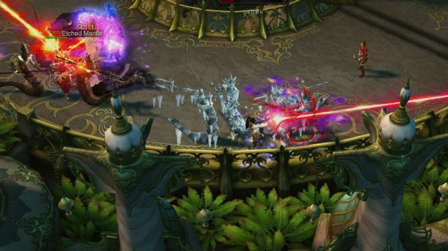

*Figure 1*

* Path of Exile: is another example of a fast-paced action RPG game that would similar to Second Soul. Like Path of Exile, Second Soul would adapt an incrementing experience requirement as the game progresses. This would provide a balanced progression as the monsters in higher level provides more experience.

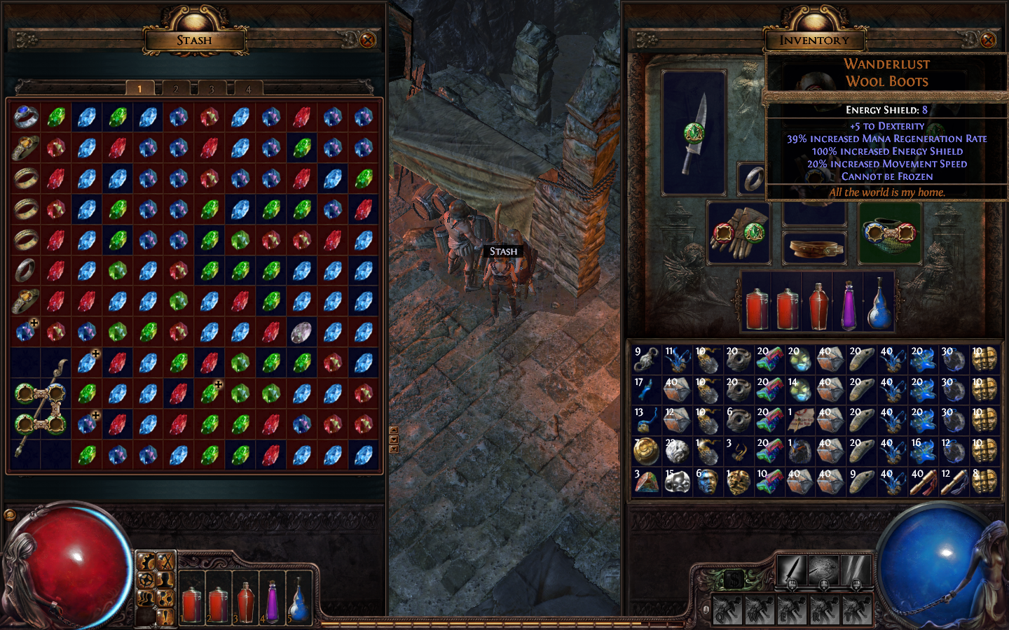

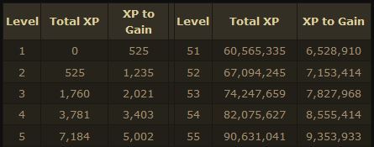

*Figure 2 Figure 3*

* Bastion: features a silent protagonist who fights his way through monster in a real-time combat mechanic that is similar to Second Soul. The game also has several levels of varying difficulties and environments as the game progresses. Instead of scavenging the world for Cores, Second Soul encourages players to explore the world for hidden treasures that could provide better items and equipment to players.

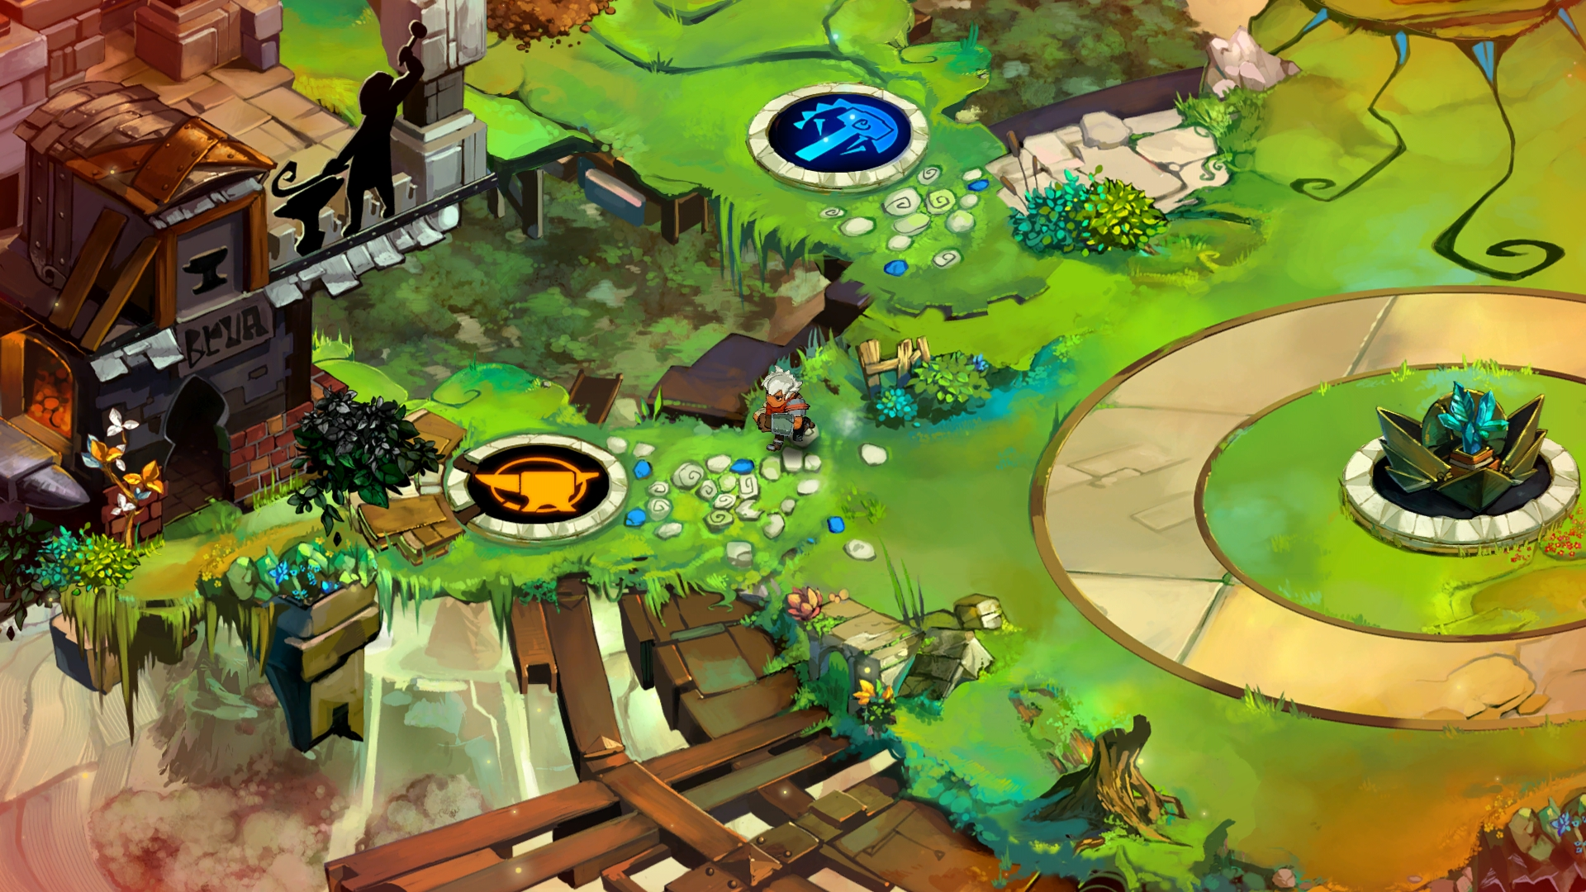

*Figure 4*

* Torchlight Series: is another action role-playing series that features several playable character classes and dungeons to explore for the players. In addition, it has pet mechanics similar to the two souls system of Second Soul. The pet system in the Torchlight series acts as a companion that supports the main player. The pets have the ability to carry items, wear equipment, and have different set of skills. Second Soul also provides the same kind of companion system in a form of a second soul character. The big difference is that the second soul character can be controlled by another player and acts as a half part that comprise the main protagonist rather than a companion.

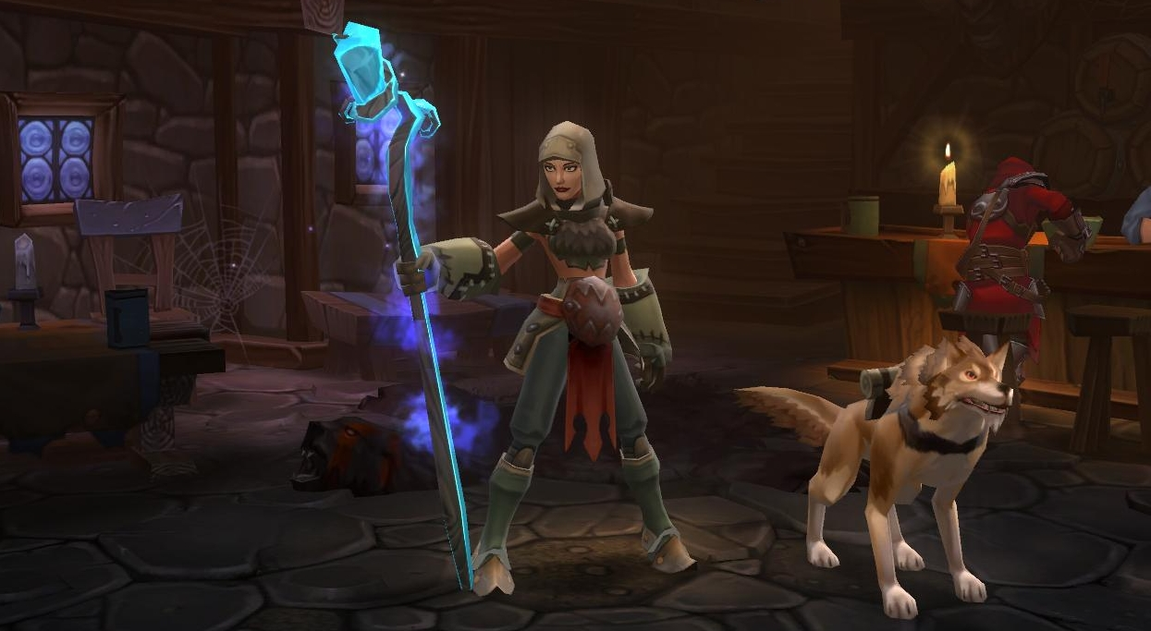

*Figure 5*

## 

## Action RPG Games (Secondary Target Audience):

* Dungeon Siege Series: is an action role-playing game that features a mixture of pause-and-go tactical management and point-and-click action combat system. Much of the combat takes place within open and closed environments (dungeons) similar to the concept of Second Soul. The game also features a companion system in the form of non-player characters and pets.

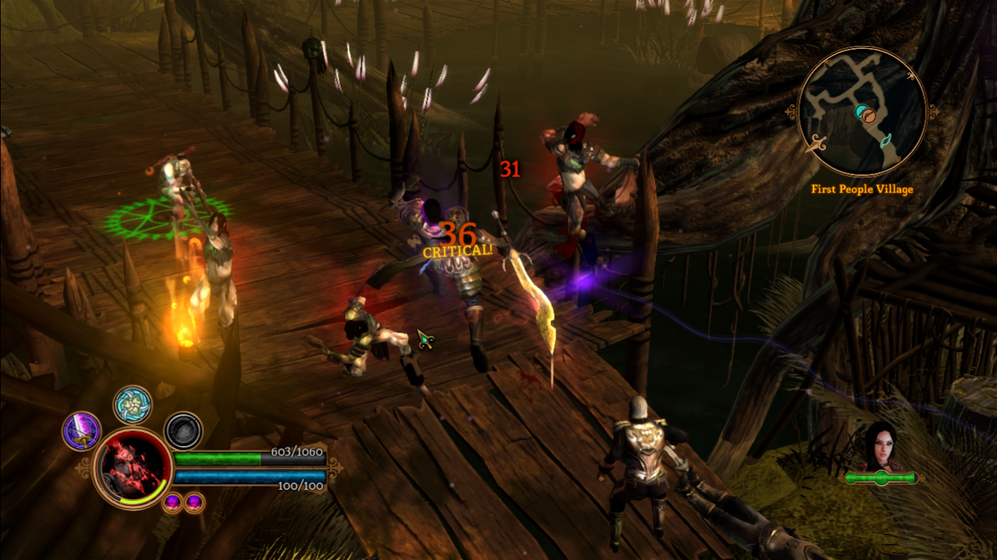

*Figure 6*

* Neverwinter Nights Series: is another action RPG game that features point-and-click action combat system with the ability to manipulate the game’s pace during combat. Like Second Soul, the game offers an extensive set of skills for players to choose from in combat. The battles also takes place in open or closed environment such as dungeons for players to explore.

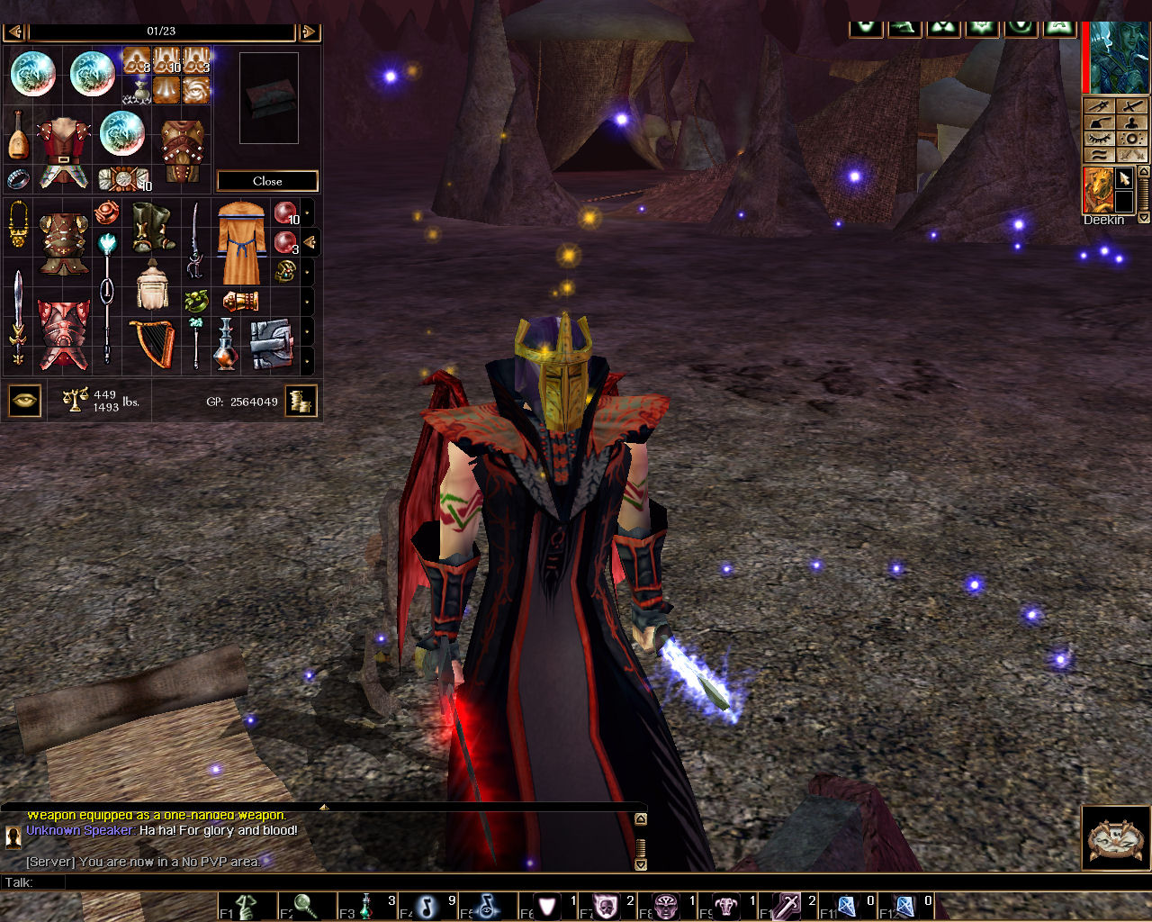

*Figure 7*

* Dragon Age Series: is a fantasy action RPG game that features fast paced combat and pausing capabilities to formulate strategies on the battlefield. The Dragon Age series possesses the same skill progression system like Second Soul, where the players have the option to unlock new variety of skills of their choice upon levelling up. All the characters (main and companions) in the game has their own inventory system with different equipment requirements based on the class in which the fans of the series would be familiar of in Second Soul. The battles also take place in instances of open environment and 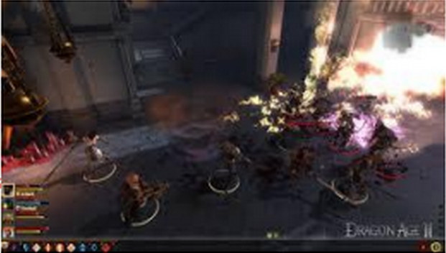dungeons.

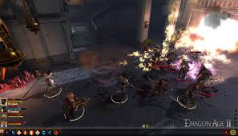

*Figure 8*